Participating in a Web Conference via Telephone
In addition to participating in a web conference via the classical method of using audio and/or video, you can also participate via telephone.

Preparation
To obtain a telephone number and access pin, you must start a web conference using a PC. You can then find the number and pin displayed in the welcome message via the chat. Note that it is not possible (until further notice) to send a number and pin in advance.
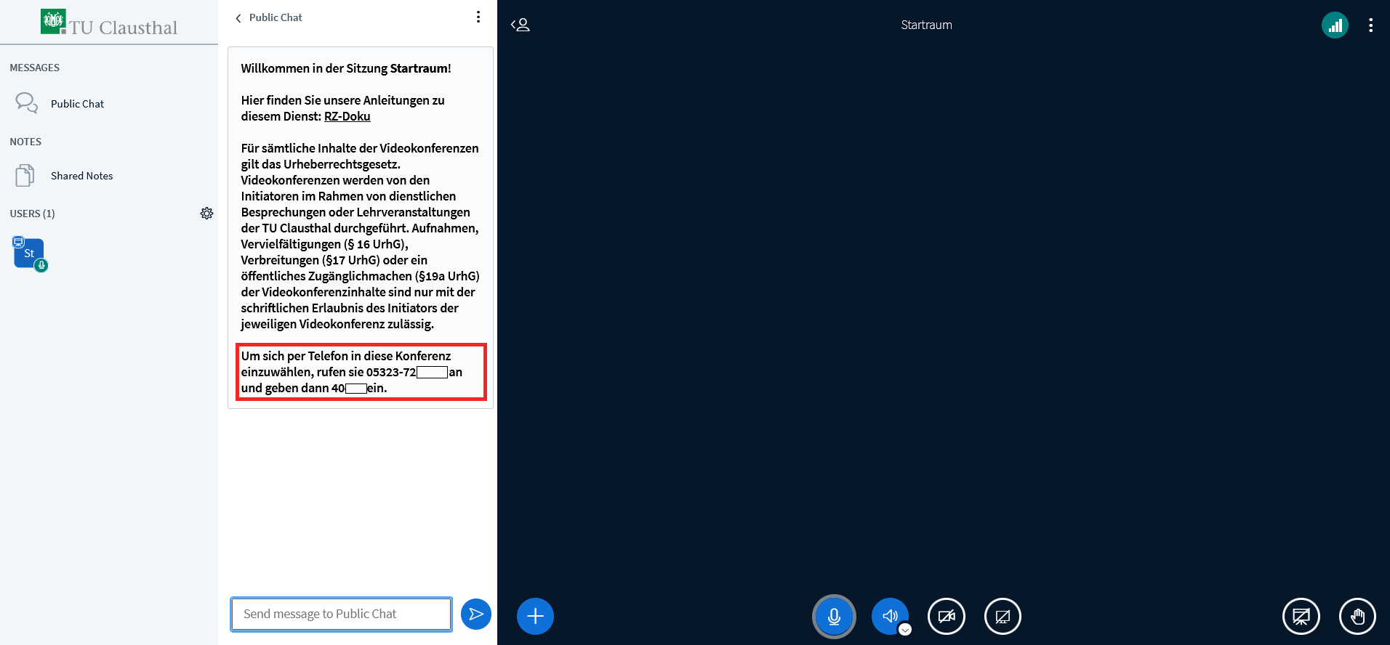

Participating by telephone
You can join a conference via a touch-tone telephone by calling the number provided by the organiser. Once the call connects, you will be prompted to enter an access pin.

Muting/Unmuting
Please press the '0' key to turn your microphone on or off.

Charges
Joining a conference via telephone is chargeable. The cost depends on your terms of contract with your telephone provider. TU Clausthal does not charge any additional fees.

Further instructions for using BigBlueButton

