[EN] Using eduroam on Ubuntu 22.04 LTS
deutsche version

1. Requirements
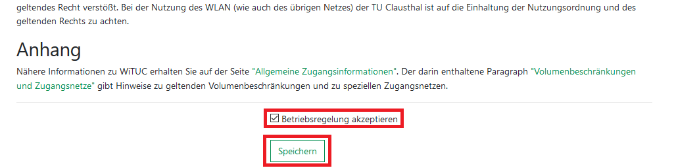
You have to accept the WiFi Conditions once to use the WiFi. WiFi Conditions: https://service.rz.tu-clausthal.de/apps/radius/policy

2. Generating an EAP-PWD password
The following method is based on „EAP-PWD“. To use this method, please follow the steps to generate your password for EAP-PWD:
- Use a web-browser to log in to https://service.rz.tu-clausthal.de with your TUC-User and the TUC-Password.
- On the mainpage choose „Nutzer-Service“ then „WLAN“ and next „EAP-PWD“:
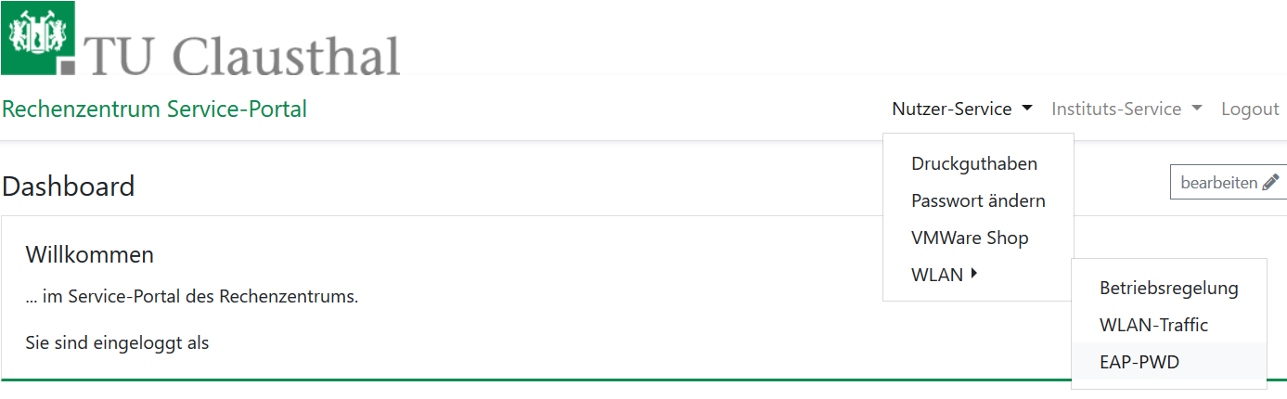Startseite service.rz
- Before generating a password, please secure that no other person is watching, because of the password being displayed unencrypted. To generate this EAP-PWD password please click on (neues) Passwort generieren.
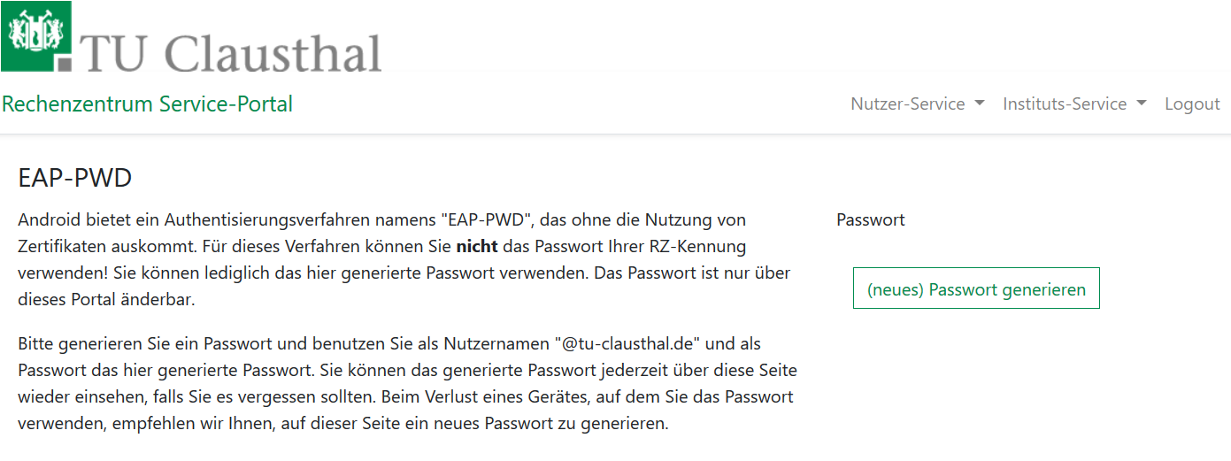
- The new EAP-PWD password will be displayed. To make it easier we recommend you to copy that password now. Important: If one of your devices, which uses this password, get lost, please generate a new EAP-PWD password to prevent misusage.
For the next steps please use the recently generated EAP-PWD-Password (not the TUC-Password).
The recently generated EAP-PWD-Passwort is not valid for any other service! For other services of the TU Clausthal use your general TUC-Password.

3. Configuration in Ubuntu 22.04 LTS
- Please click in Gnome-Panel on theNetwork-Icon.
- Choose „eduroam“.
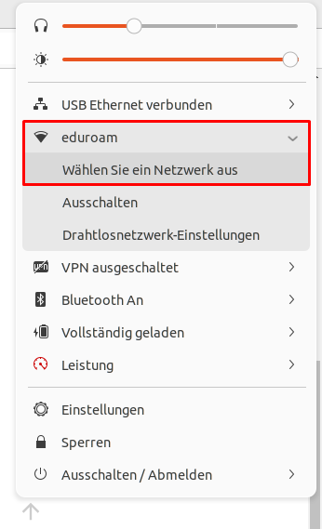
- A dialog will open now.
- Choose „eduroam“.
- Now click on „Connect“.
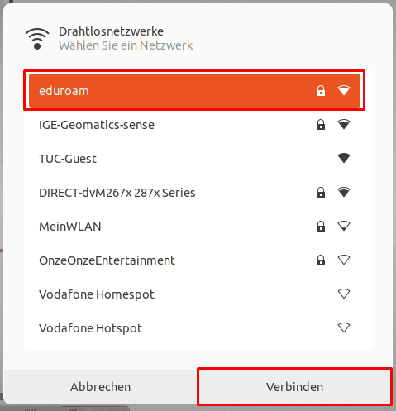
- A configuratipn-dialog will open now.
- On authentication choose the method PWD.
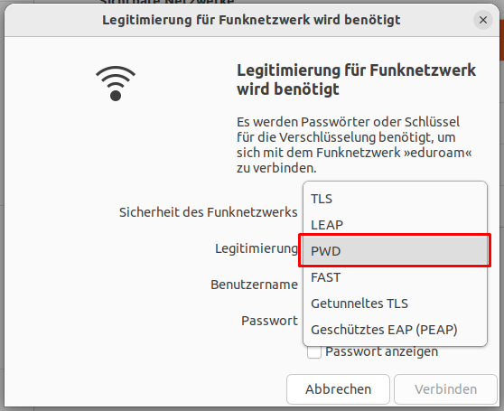
- Set „<TUC-User>@tu-clausthal.de“ as the username.
- Set the EAP-PWD-Password as the password.
- Now click on „Connect“.
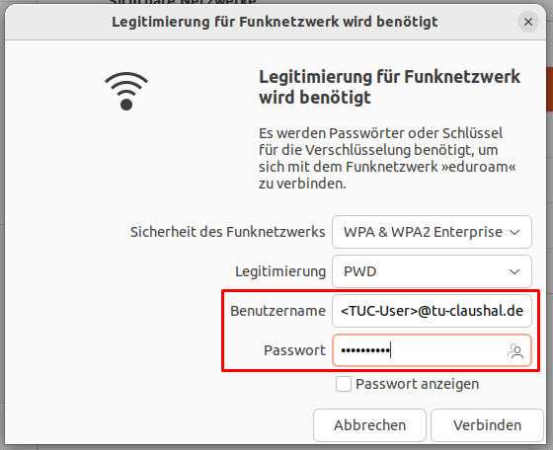
- The connection will be initiated .
- If successfully, following windows will open:


