Using eduroam with MacOS X
deutsche version

Requirements
You have to accept the WiFi Conditions once to use the WiFi.
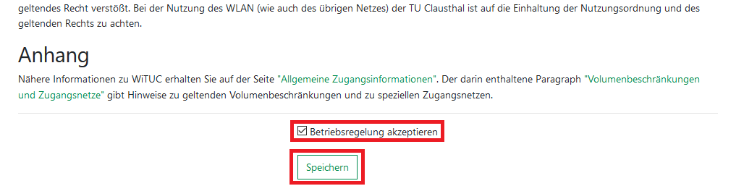
WiFi Conditions: https://service.rz.tu-clausthal.de/apps/radius/policy

Configuration (MacOS X 10.7 to 10.13)
Please download the newest eduroam profile and start the installation.
Configuration Profile: eduroam
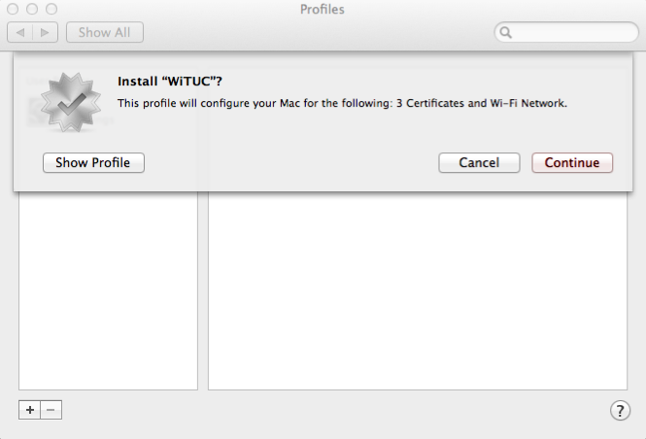
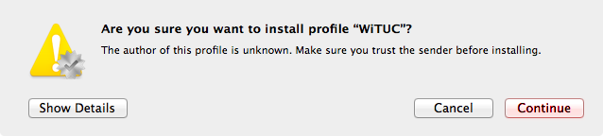
The configuration profile isn't signed for technical reason. You can have a look on the profile to be sure, it will not do anything unexpected.
- Enter your UserID and add @tu-clausthal.de behind it, so it looks like the following: „mmus17@tu-clausthal.de“ . Then enter the belonging password and click on Install.
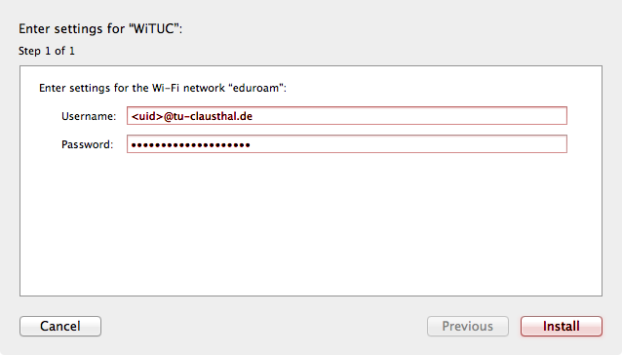
- After the installation is complete, you´ll get a summary of all changes that were taken to your system.
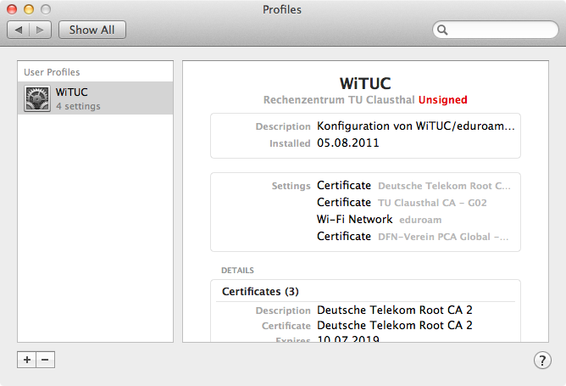
- Eduroam is installed successfully.

Check the Installation
- In your System Settings below Network / Advanced you can check the tab 802.1x, if the profile „WiFi (eduroam)“ installed correctly.
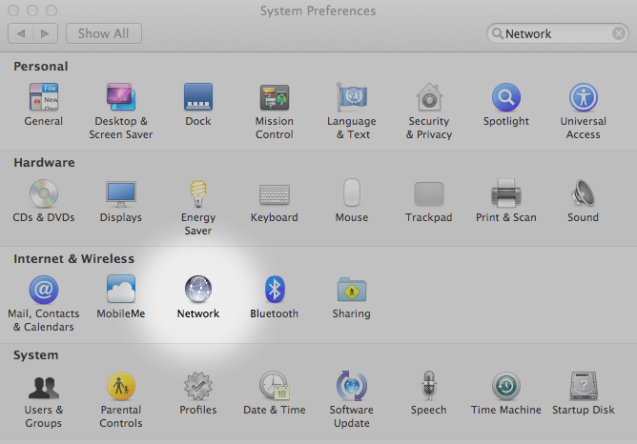
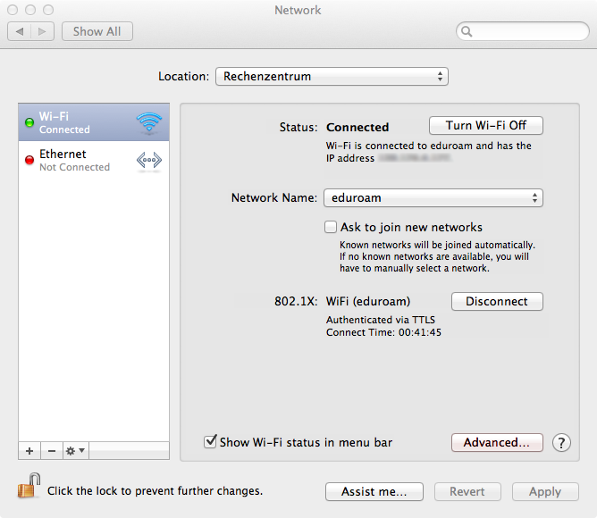
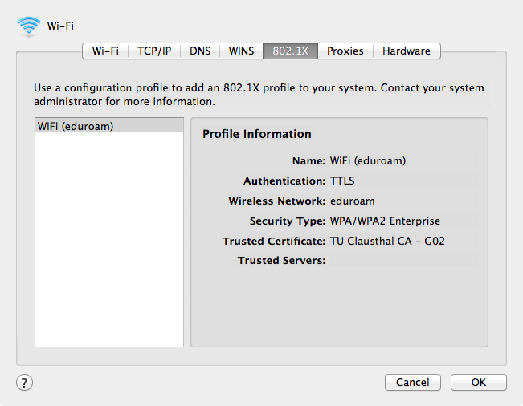
- Now you should be able to connect to eduroam.

