Participation in a web conference via telephone
In a BigBlueButton web conference, you can also participate by telephone, in addition to the regular method via computer or mobile phone.

Preparation by the organizer
The organizer of a conference must start the voice conference on the computer to obtain the telephone number and the access pin. It is not possible (until further notice) to send the telephone number and the access pin in an invitation in advance.
As the organizer, you will find the phone number and access pin in the welcome message in the chat.
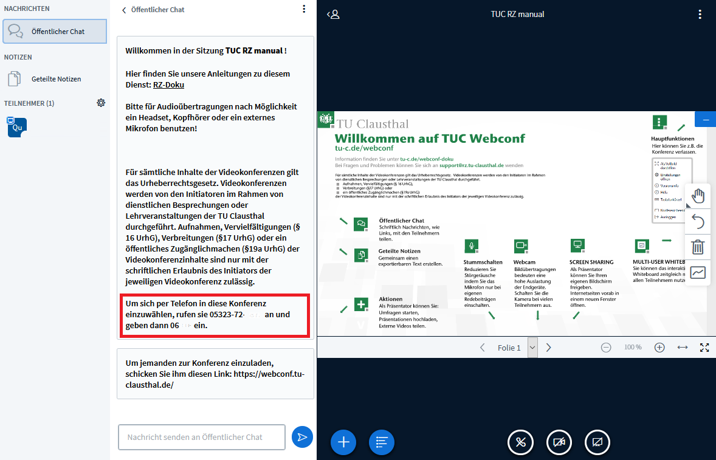

Participation in the conference by telephone
You can join the conference by calling the telephone number provided by the organizer using a telephone or mobile phone. After the call connects, you will be asked to enter the access pin.
Hints: Speed dialling without the Clausthal-Zellerfeld area code (e.g. only „8873“) does not work in general. In addition, calls into the conference from any telephone set from TU Clausthal are not activated.

Charges
The telephone dial-up is with costs. The charge depends on the terms of the contract with the user's telephone provider. For dial-ups from abroad, the prices depend on the roaming option booked. TU Clausthal does not charge any additional telephone fees.

Further instructions on the topic BigBlueButton in the RZ documentation

