Plugin for Stud.IP to integrate BigBlueButton
You can also directly create web conference rooms in Stud.IP events with the „Meetings“ plugin.
However, we recommend web conferences rather for smaller classes with a high level of interaction, such as tutorials, practice groups, consulting hours, etc.

Instructions for Meeting-Plugin
If you want to activate the meeting plugin in your Stud.IP event, click on More…
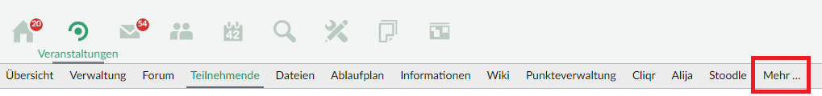
In the list of available plugins, find the plugin Meetings.
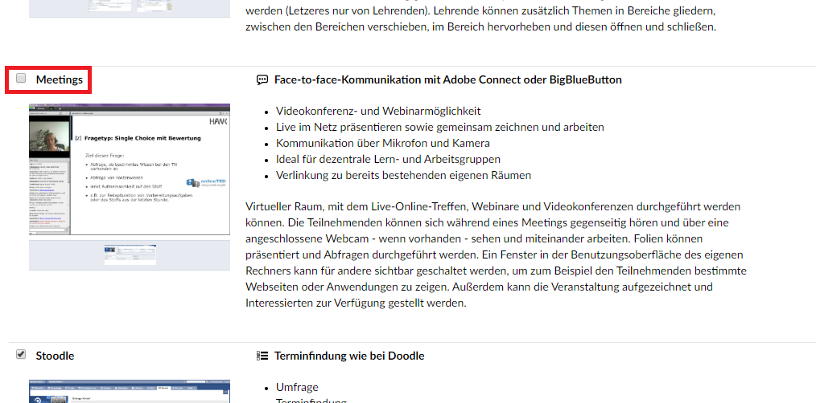
Afterwards the plugin is located in the upper bar of the Stud.IP event.
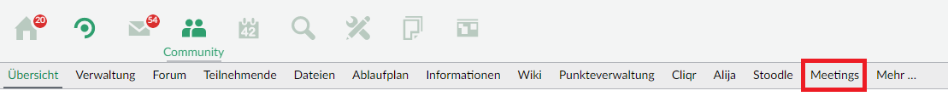
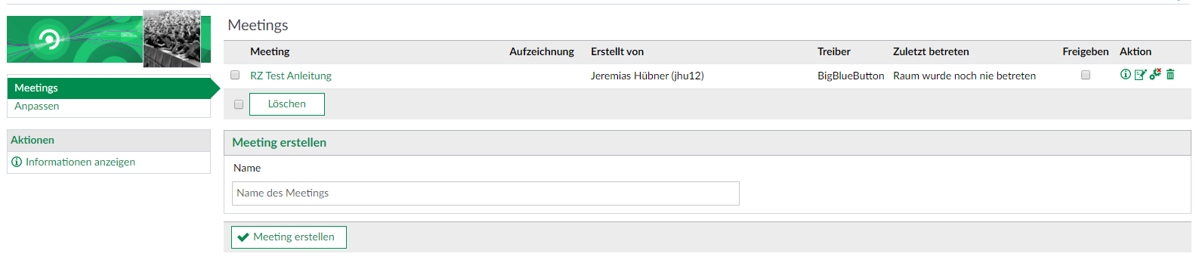
You can now directly create web conference rooms.
Important: before you have checked the „Share“ checkbox, this meeting is not visible to your students.
By default a meeting has the following setting: 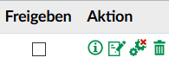
This means that the participants have limited rights, i.e. they are not allowed to moderate in the video conference.
With a click on this symbol: you can change the rights so that the participants in the meeting have the same rights as you.
If you want to appoint another person, e.g. a tutor, as moderator in the meeting, please leave the setting in Stud.IP as in the default and give the person the appropriate right directly in the meeting, as described under Configuration of the participants.

Further instructions on the topic BigBlueButton in the RZ documentation

